CODING CONTEST 1

QUESTION 1

CODING:

**package** com.cc1;

**import** org.openqa.selenium.By;

**import** org.openqa.selenium.WebDriver;

**import** org.openqa.selenium.WebElement;

**import** org.openqa.selenium.chrome.ChromeDriver;

**import** org.openqa.selenium.chrome.ChromeOptions;

**import** io.github.bonigarcia.wdm.WebDriverManager;

**public** **class** q1 {

**public** **static** **void** main(String[] args) {

// **TODO** Auto-generated method stub

WebDriverManager.*chromedriver*().setup();

ChromeOptions co=**new** ChromeOptions();

co.addArguments("--remote-allow-origins=*");

WebDriver driver=**new** ChromeDriver(co);

driver.get("https://www.saucedemo.com/");

driver.manage().window().maximize();

WebElement user = driver.findElement(By.*id*("user-name"));

user.sendKeys("standard_user");

WebElement pass = driver.findElement(By.*id*("password"));

pass.sendKeys("secret_sauce");

WebElement login = driver.findElement(By.*id*("login-button"));

login.click();

driver.findElement(By.*xpath*("//*[@id=\"add-to-cart-sauce-labs-backpack\"]")).click();

String cartCount = driver.findElement(By.*xpath*("/html/body/div/div/div/div[1]/div[1]/div[3]/a/span")).getText();

driver.findElement(By.*xpath*("/html/body/div/div/div/div[1]/div[1]/div[3]/a")).click();

String product = "Sauce Labs Backpack";

driver.findElement(By.*xpath*("//*[@id=\"checkout\"]")).click();

driver.findElement(By.*xpath*("//*[@id=\"first-name\"]")).sendKeys("ABCD");

driver.findElement(By.*xpath*("//*[@id=\"last-name\"]")).sendKeys("X");

driver.findElement(By.*xpath*("//*[@id=\"postal-code\"]")).sendKeys("12345");

driver.findElement(By.*xpath*("//*[@id=\"continue\"]")).click();

System.***out***.println("Name of the product: " + driver.findElement(By.*xpath*("/html/body/div/div/div/div[2]/div/div[1]/div[3]/div[2]/a/div")).getText());

System.***out***.println("Price of the product: " + driver.findElement(By.*xpath*("/html/body/div/div/div/div[2]/div/div[1]/div[3]/div[2]/div[2]/div")).getText());

}

}

OUTPUT:

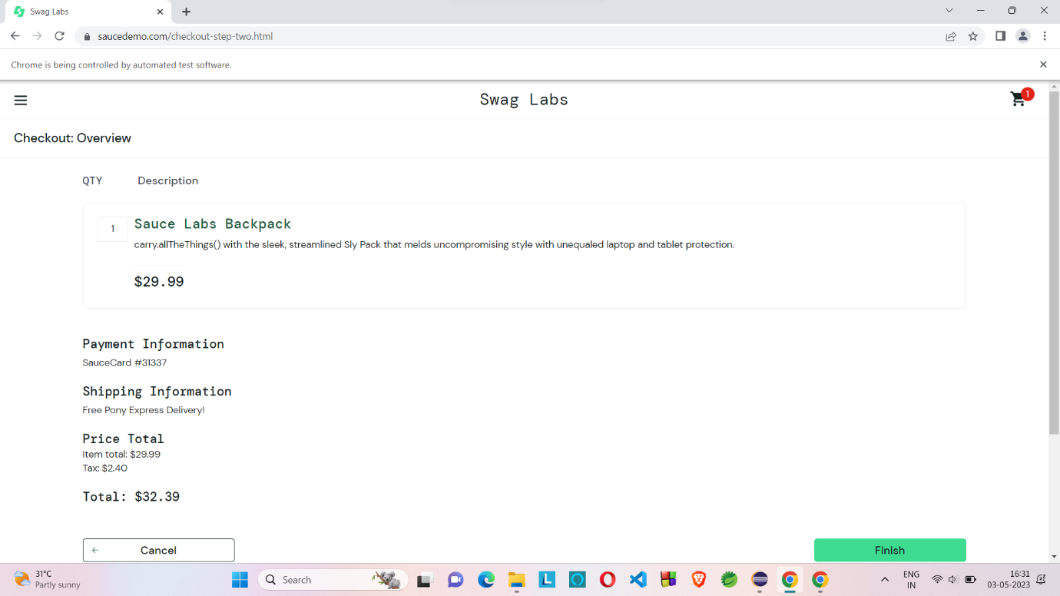

QUESTION 2

CODING

**package** com.cc1;

**import** org.openqa.selenium.By;

**import** org.openqa.selenium.WebDriver;

**import** org.openqa.selenium.WebElement;

**import** org.openqa.selenium.chrome.ChromeDriver;

**import** org.openqa.selenium.chrome.ChromeOptions;

**import** io.github.bonigarcia.wdm.WebDriverManager;

**public** **class** q2 {

**public** **static** **void** main(String[] args) **throws** InterruptedException {

// **TODO** Auto-generated method stub

WebDriverManager.*chromedriver*().setup();

ChromeOptions co=**new** ChromeOptions();

co.addArguments("--remote-allow-origins=*");

WebDriver driver=**new** ChromeDriver(co);

driver.get("https://www.saucedemo.com/");

Thread.*sleep*(2000);

driver.manage().window().maximize();

WebElement name=driver.findElement(By.*xpath*("//*[@id=\"user-name\"]"));

name.sendKeys("standard_user");

Thread.*sleep*(2000);

WebElement pwd=driver.findElement(By.*xpath*("//*[@id=\"password\"]"));

pwd.sendKeys("secret_sauce");

Thread.*sleep*(2000);

WebElement btn=driver.findElement(By.*xpath*("//*[@id=\"login-button\"]"));

btn.click();

Thread.*sleep*(2000);

WebElement c1=driver.findElement(By.*xpath*("//*[@id=\"header_container\"]/div[2]/div/span/select"));

c1.click();

Thread.*sleep*(2000);

WebElement c2=driver.findElement(By.*xpath*("//*[@id=\"header_container\"]/div[2]/div/span/select/option[1]"));

c2.click();

Thread.*sleep*(2000);

String e1=driver.findElement(By.*xpath*("//*[@id=\"item_4_title_link\"]/div")).getText();

System.***out***.println("A to Z Order's 1st Product Title: "+e1);

WebElement c3=driver.findElement(By.*xpath*("//*[@id=\"header_container\"]/div[2]/div/span/select/option[2]"));

c3.click();

Thread.*sleep*(2000);

String e2=driver.findElement(By.*xpath*("//*[@id=\"item_3_title_link\"]/div")).getText();

System.***out***.println("Z to A Order's 1st Product Title: "+e2);

Thread.*sleep*(1000);

WebElement c4=driver.findElement(By.*xpath*("//*[@id=\"header_container\"]/div[2]/div/span/select/option[3]"));

c4.click();

Thread.*sleep*(2000);

String e3=driver.findElement(By.*xpath*("//*[@id=\"item_2_title_link\"]/div")).getText();

System.***out***.println("Low to High Order's 1st Product Title: "+e3);

WebElement c5=driver.findElement(By.*xpath*("//*[@id=\"header_container\"]/div[2]/div/span/select/option[4]"));

c5.click();

Thread.*sleep*(2000);

String e4=driver.findElement(By.*xpath*("//*[@id=\"item_5_title_link\"]/div")).getText();

System.***out***.println("High to Low Order's 1st Product Title: "+e4);

Thread.*sleep*(1000);

}

}

OUTPUT:

